Covid Detection

**Documentation for COVID-19 CT Scan Prediction ML Model**

**Overview:**

The provided code implements a machine learning model for predicting COVID-19 using CT scans of patients. The code uses various deep learning techniques, including Artificial Neural Networks (ANN), Convolutional Neural Networks (CNN) with and without data augmentation and dropout regularization, and Transfer Learning using MobileNet V2.

**Data:**

The CT scan images are organized into two categories: 'covid' and 'not_covid'. 'covid_images_dict' and 'covid_labels_dict' are dictionaries that store the paths of the CT scan images and their corresponding labels respectively. 'X' and 'y' are lists that will store the resized images and their labels, respectively.

Example image of ‘covid’:

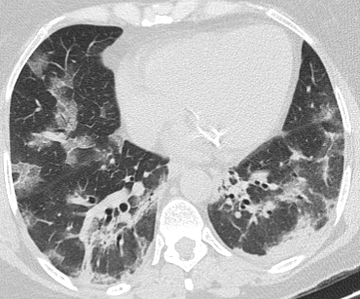

Example image of ‘not_covid’:

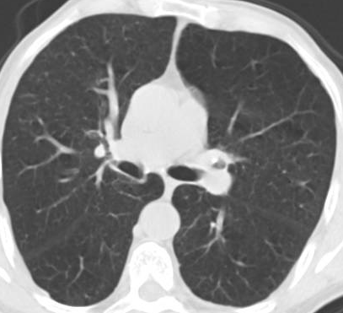

**Artificial Neural Networks (ANN):**

An ANN model is implemented using Keras. The model consists of multiple dense layers with different numbers of units and activation functions. The model is compiled with the Adam optimizer, sparse categorical cross-entropy loss, and accuracy as the evaluation metric. The 'X_train' and 'y_train' are used as training data for fitting the ANN model. After training for 5 epochs, the model achieved an accuracy of 0.57.

**Convolutional Neural Networks (CNN)**:

Two CNN models are implemented with different configurations. The first CNN model (cnn1) does not use data augmentation or dropout regularization. It consists of multiple convolutional and pooling layers followed by flatten and dense layers. The model is compiled with the Adam optimizer, sparse categorical cross-entropy loss, and accuracy as the evaluation metric. The 'X_train_scaled' and 'y_train' are used as training data for fitting the cnn1 model. After training for 25 epochs, the model achieved an accuracy of 0.9962.

The second CNN model (cnn2) uses data augmentation and dropout regularization. It includes a data augmentation layer that performs random horizontal flipping, rotation, and zooming of the images. It also includes dropout layers after some convolutional layers to regularize the model. The model is compiled with the Adam optimizer, sparse categorical cross-entropy loss, and accuracy as the evaluation metric. The 'X_train_scaled' and 'y_train' are used as training data for fitting the cnn2 model. After training for 30 epochs, the model achieved an accuracy of 0.9059.

The third CNN model (cnn3) uses only dropout regularization. It consists of multiple convolutional and pooling layers followed by flatten and dense layers. Dropout layers are added after some convolutional and dense layers to regularize the model. The model is compiled with the Adam optimizer, sparse categorical cross-entropy loss, and accuracy as the evaluation metric. The 'X_train_scaled' and 'y_train' are used as training data for fitting the cnn3 model. After training for 30 epochs, the model achieved an accuracy of 0.9898.

**Transfer Learning - MobileNet V2:**

Transfer learning using MobileNet V2, a pre-trained model available in TensorFlow Hub, is implemented. The 'feature_extractor_model' is used to load the MobileNet V2 model without the top classification layer. The pre-trained model is compiled with the Adam optimizer, sparse categorical cross-entropy loss, and accuracy as the evaluation metric. The 'X_train_scaled' and 'y_train' are used as training data for fitting the MobileNet V2 model. After training for 40 epochs, the model achieved an accuracy of 0.9892.

**Confusion Matrix For Transfer Learning Model:**

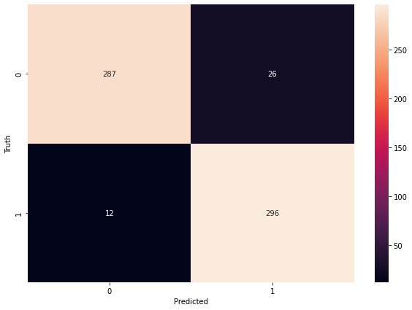

Here 1:’covid

0:’not_covid’

**Conclusion:**

The implemented ML model for predicting COVID-19 using CT scans of patients shows promising accuracy results. Further optimization and fine-tuning of the model parameters may be necessary to achieve higher accuracy. Additionally, thorough validation and testing on diverse datasets are recommended to ensure the model's reliability and generalization capability.